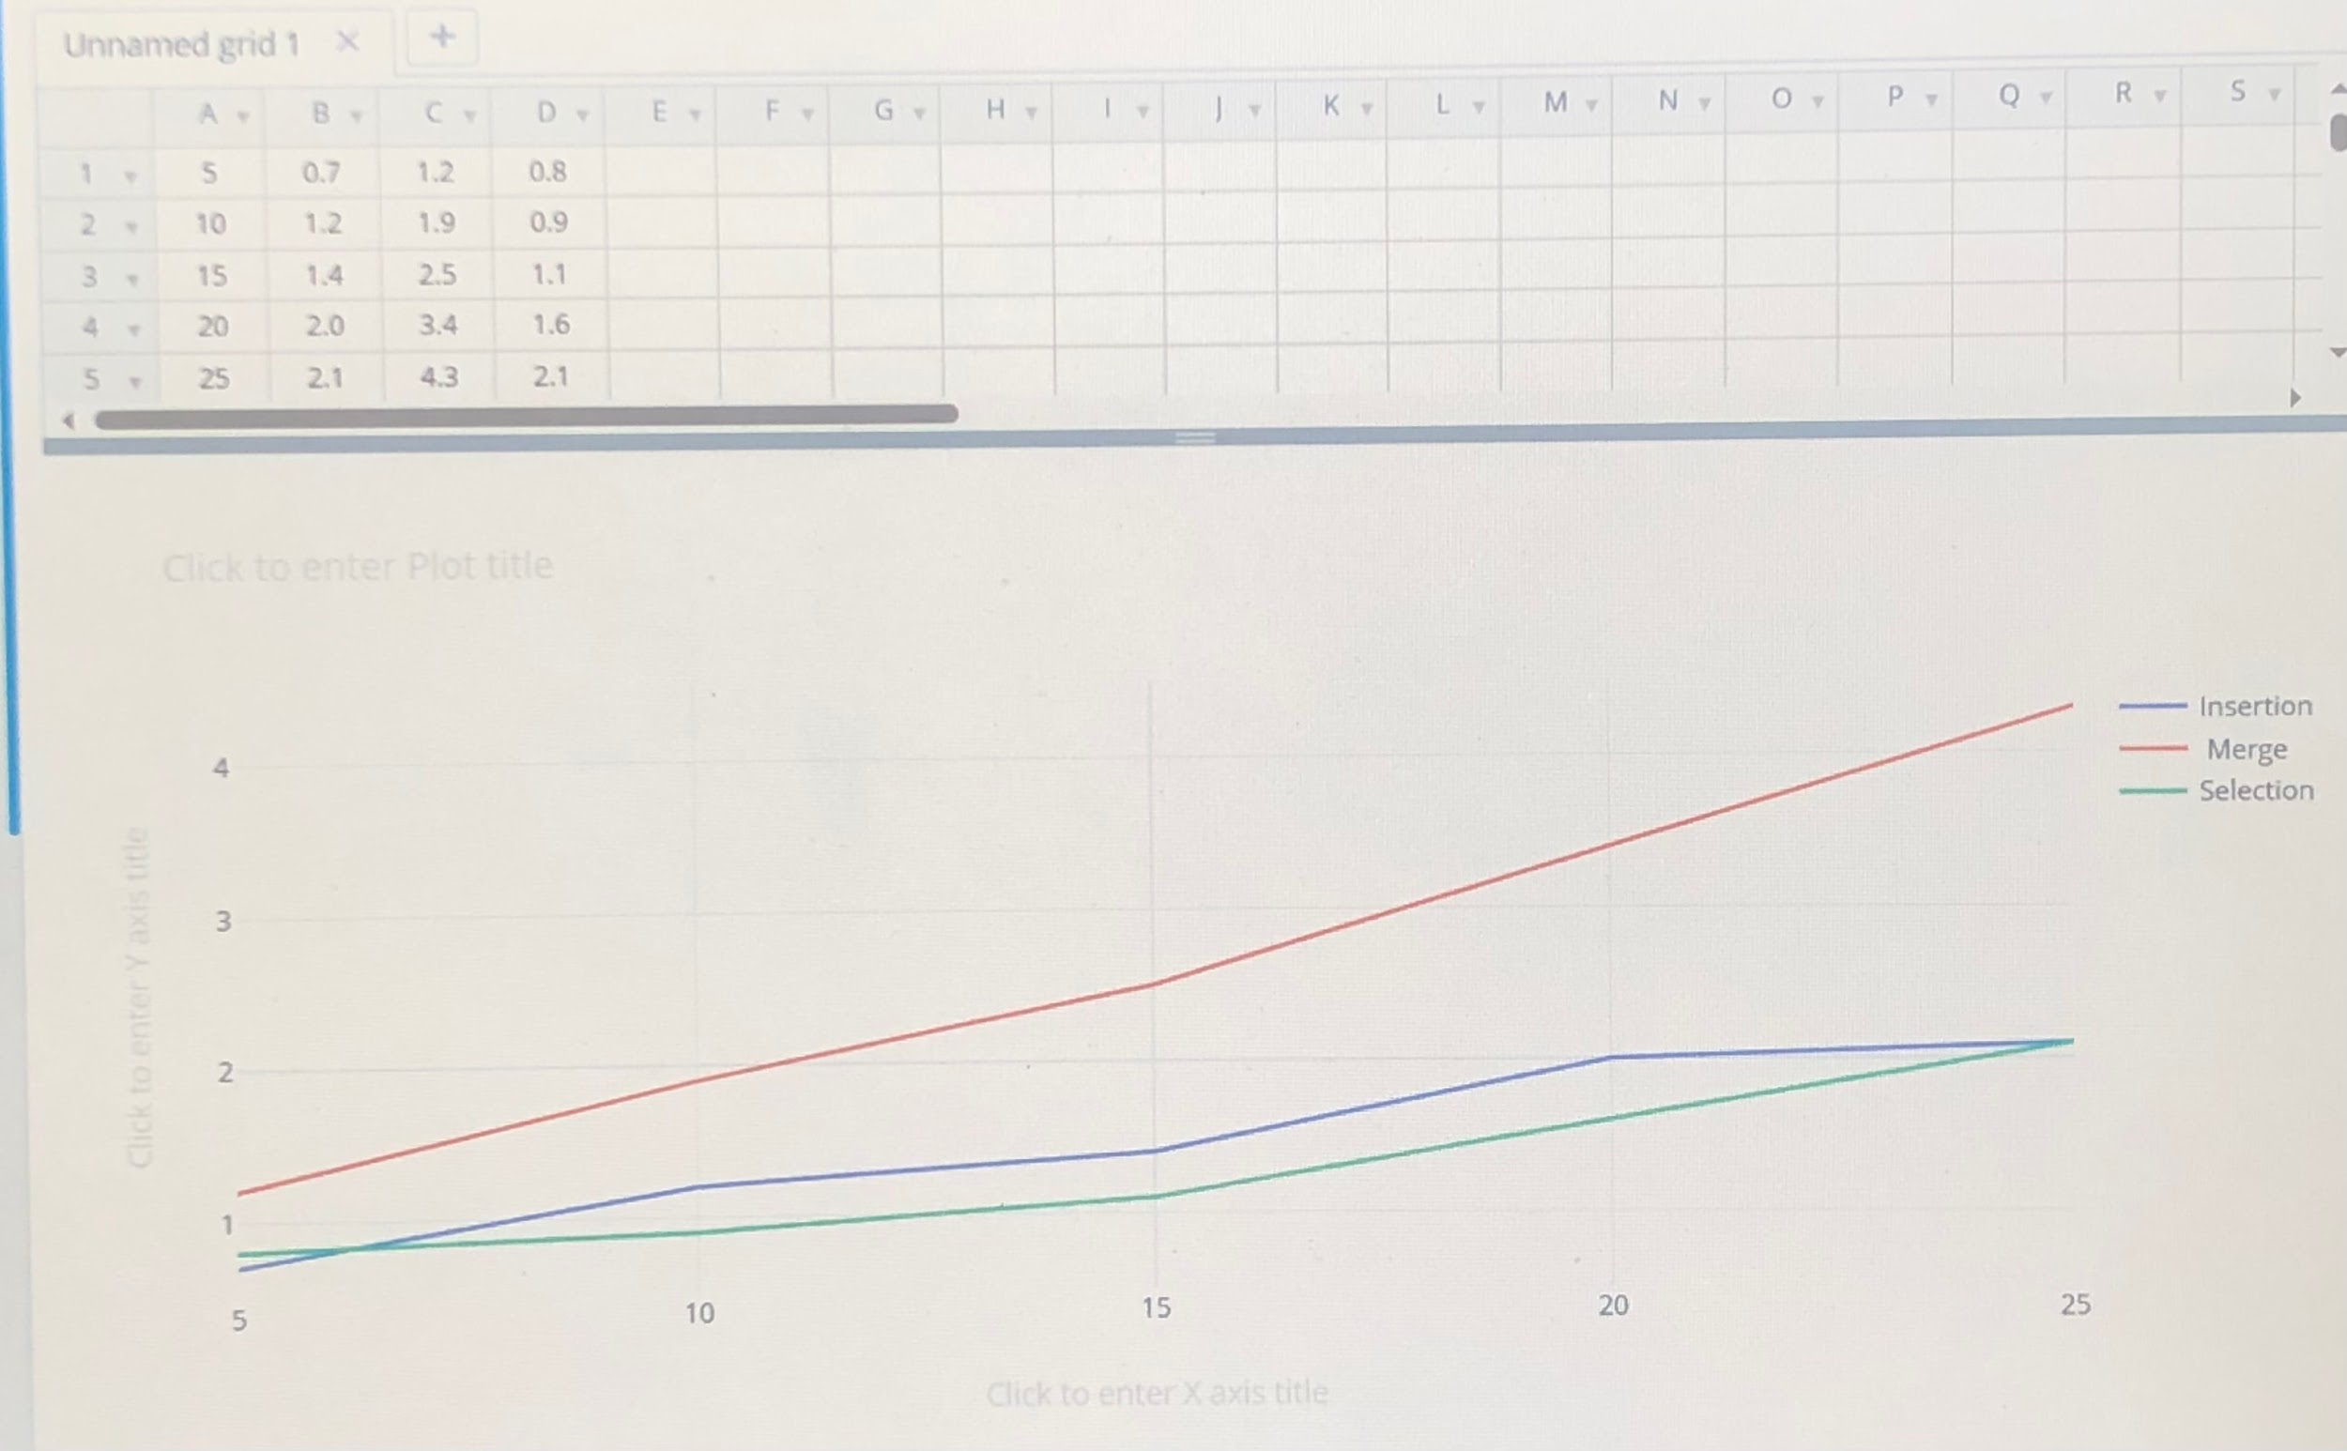

My analysis of the algorithms is that the merge sort algorithm sorts the arrays faster than the insertion and selection sort algorithms therefore it may be the best algorithm to use especially as the elements in the array increase to a larger numbet